DNA Structure
- Describe the relationship between polymers and monomers.
- DNA and RNA are what kind of polymer?
- DNA and RNA strands are made up of repeating units (monomers) called ________________.
- Draw and label the three parts of a nucleotide.

- Using the ladder analogy for DNA structure, what two parts of the nucleotide make up the sides of the ladder?
- Using the ladder analogy for DNA structure, what part of the nucleotide make up the steps of the ladder?
- What are the four bases of DNA and how do they base pair?
- What kind of chemical bond holds the two bases of DNA together?
DNA Discovery
- How did Griffith’s experiment contribute to the discovery that DNA is the molecule that carries genetic information?
- How did Avery’s experiment contribute to the discovery that DNA is the molecule that carries genetic information?
- How did Hershey and Chase’s experiment contribute to the discovery that DNA is the molecule that carries genetic information?
- How did Rosalind Franklin contribute to the discovery of the structure of DNA?
- How did James Watson, Francis Crick and Maurice Wilkens contribute to the discovery of DNA?
DNA Replication
- What is DNA replication?
- Describe the importance of DNA replication to living things?
- In what phase of the cell cycle, does DNA replication occur.
- Explain what it means to be and why we consider DNA replication semiconservative.
- Describe the process of DNA replication.
- The old strand of DNA that is read to create the new strand is called the ________________ strand.
- The new strand that is created by base pairing with the old strand is called the ___________________ strand.
- What do we call the enzyme that “unzips” DNA by breaking the hydrogen bonds between bases?
- What do we call the enzyme that “builds” the complementary strand by base pairing?
- What is the building material for the complementary strand?
RNA Structure
- Name at least five differences between DNA and RNA.
- RNA has the ability to fold in on itself to create three dimensional forms. This allows for there to be many types of RNA. Fill in the information for the three types of RNA that we learned about.
 | Full Name | Function | Location
mRNA
tRNA
rRNA
- What is a codon and where can it be found?
- What is an anticodon and where can it be found?
Proteins
- Why are proteins important to life?
- Proteins are polymers. What is the monomer of a protein?
- How many types of amino acids are there?
- A gene is composed of many codons. One codon codes for one ____________ ____________. Many codons read together code for a _________________.
- In what organelle are proteins made?
Central Dogma of Biology/Protein Synthesis
- What is the Central Dogma of Biology?
- Name the process that copies the information found on a DNA strand onto an RNA strand.
- What type of RNA is created during the above process?
- Name the process where transfer (t)RNA’s anticodons base pair with messenger (m)RNA’s codons thus allowing the Ribosome to polymerize amino acids and print proteins.
- Why do we need RNA?
- Explain how 64 codons can code for only 20 amino acids.
- During translation, how does tRNA know what amino acids to bring to the ribosome?
- Using your knowledge of base pairing, codons and anti-codons, determine the amino acid sequence for the following strand of DNA.
DNA: | TAC | GGG | CCT | ATA | CGC | TAC | TAC | CAT | GGA | TCG | GGT | ACG | CGT | ATA | CCG | ACA | ATT
mRNA:
(codons)
tRNA:
(Anti-codons)
Amino Acids
- Fill in the blanks on the image below.
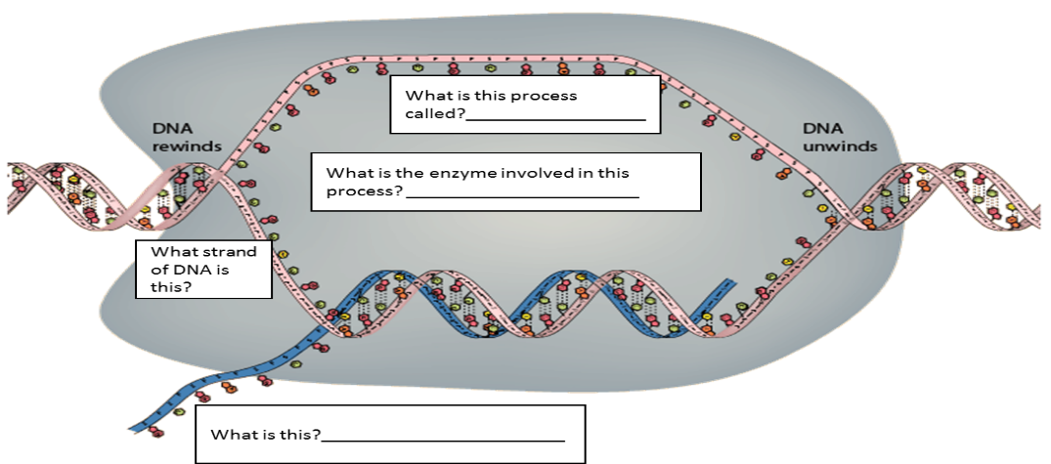
Briefly describe what is happening in this process.
Fill in the blanks on the image below?
Briefly describe what is happening in this process.
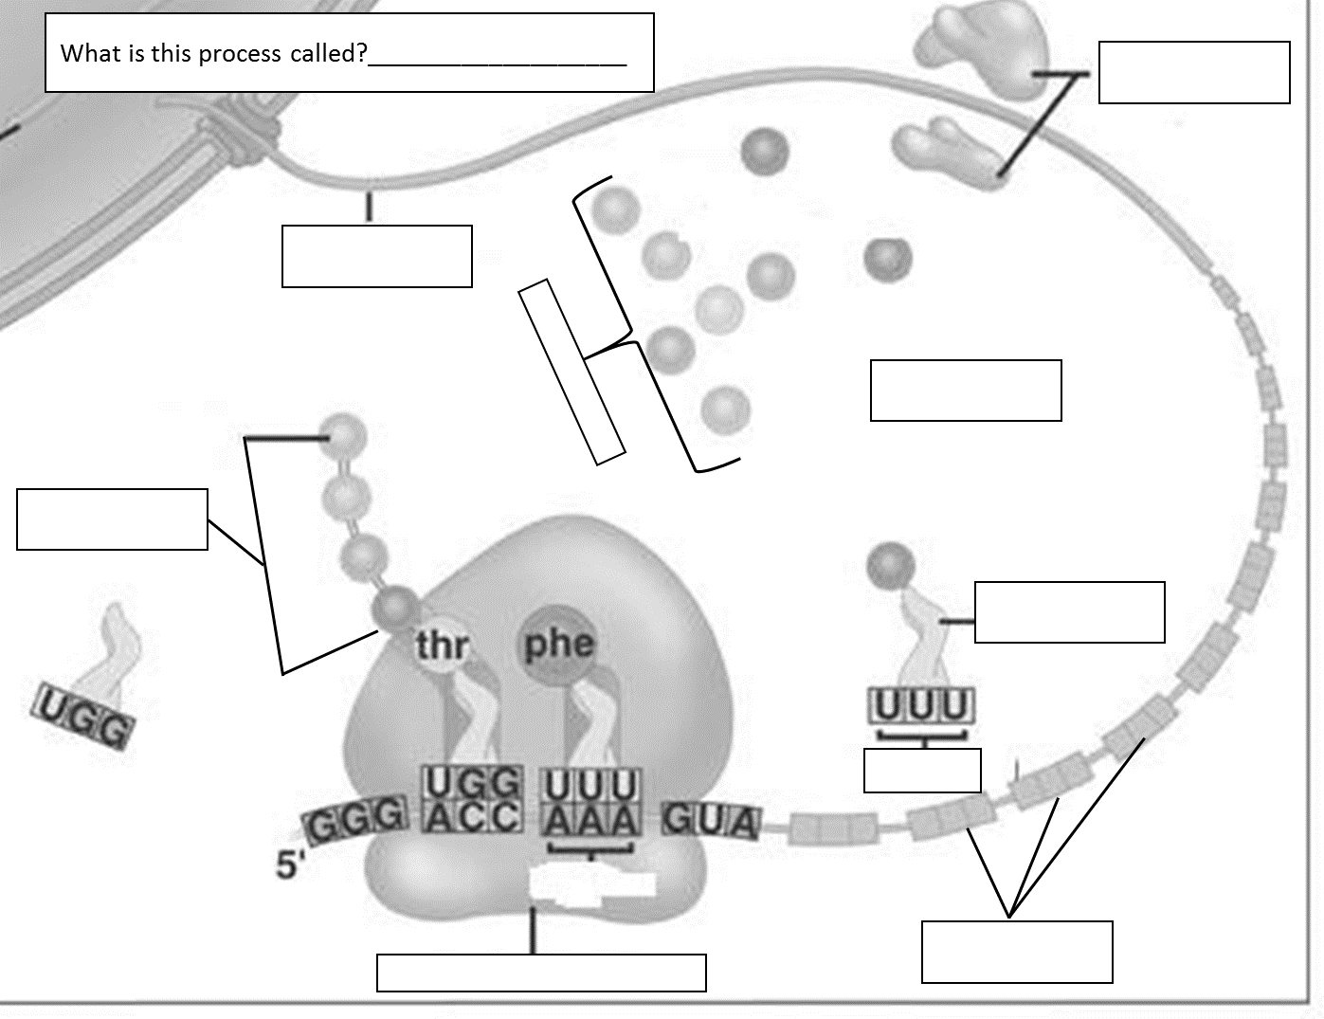
Mutations
- What is a mutation?
- How can mutations affect protein synthesis?
- Are all mutations bad?
- Using the DNA strands below, circle the mutations and identify the type of mutation. Explain how this mutation might affect the process of protein synthesis.
Normal | TAC | ATT | CCG | CAT | GAG | CGT | ACG | ATA | AAA | TCG | CCG | ACG | GCC | TTT | ATT
Mutation #1 | TAC | ATT | CCA | CAT | GAG | CGT | ACG | ATA | AAA | TCG | CCG | ACG | GCC | TTT | ATT
Type: | Mutation effect:
Mutation #2 | TTC | ATT | CCG | CAT | GTG | CGT | AAG | ATA | AAA | TCG | CCG | ACG | GCC | TTT | ATC
Type: | Mutation effect:
Mutation #3 | TAC | ATT | TCC | GCA | TGA | GCG | TAC | GAT | AAA | ATC | GCC | GAC | GGC | CTT | TAT
Type: | Mutation effect:
Mutation #4 | TAC | TTT | CCG | CAT | GAG | CGT | ACG | ATA | AAA | TCG | CCG | ACG | GCC | TTT | AT
Type: | Mutation effect:

- Match the following chromosomal mutations with the correct term.
Original Chromosome (ABC*DEF)
- ___AC * DEF A. Inversion
- ___ABBC * DEF B. Translocation
- ___AED * CBF C. Deletion
- ___ABC * JKL D. Duplication
GHI * DEF

