I know the definitions of the following Latin Root Words.
- Cyto - _______ 2. Scope - ____________ 3. Bi - _________ 4. Pro - _________

5. Eu - __________ 6. Kary - __________ 7. Nucle - ___________ 8. Mito - _________
9. Chondrion - ___________ 10. Reticulum - ________ 11. Hyper - _________ 12. Hypo - __________
13. Tonic - ____________ 14. Osmos - __________ 15. Endo _________ 16. Exo - __________
I know the three parts of the cell theory.
- ______________________________________________________
- ______________________________________________________
- ______________________________________________________

I know the difference between a prokaryotic cell and a eukaryotic cell
Prokaryotes Only | Both Prokaryotes and Eukaryotes | Eukaryotes Only
27. | 28. | 29.
30. | 31. | 32
33. |  | 34
- Pro + Kary = ____________________
- Eu + Kary = ____________________

35. Draw a prokaryote cell:
36. Draw a eukaryote cell:

I can identify an organelle and explain its function.
# | Identify | Function
37.
38.
39.
40.
41.
42.
43.
45.
46.
47.
48.
49.
50.
51.
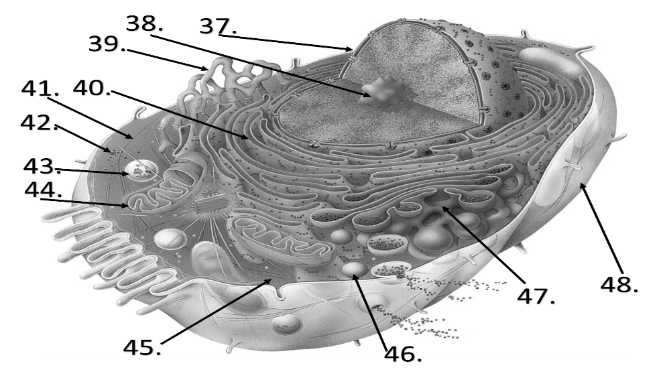

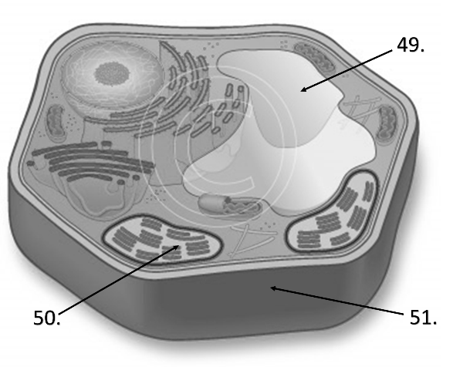
52. What three organelles do plant cells have that animal cells do not have?
1. 2. 3.

I can identify the parts that make up the cellular membrane as well as their properties and functions.
57. The cell membrane is semi-permeable. What does semi-permeable mean?
58. The majority of the cell membrane is made up of phospholipids. Draw a phospholipid and describe its properties.

59. Draw a picture showing how phospholipids arrange themselves when they are submerged in water?

61. What other things are found in a cell membrane?

I know the components and properties of solutions.
62. What are the two parts of a solution? ______________ & _______________
63. How do we determine the concentration of a solution?
64. What is a concentration gradient?
65. Describe equilibrium.
66. When we compare solutions together we use three terms to describe their properties. Define the three terms.
1. Hypertonic –
2. Hypotonic –
3. Isotonic –
Compare the solutions and label them as either isotonic, hypertonic or hypotonic
67. 68. 69.
90% H2O
10% Solute
40% H2O
60% Solute
63% H2O
37% Solute
90% H2O
10% Solute
50% H2O
50% Solute
50% H2O
50% Solute

Students will be able to describe the passive and active modes of transport.
71. What are the two solutions (fluids) that are involved in cell transport?
1. 2.
72. Describe the difference between active transport and passive transport.
73. Fill in the blanks with the correct modes of transport
No Energy
Energy

Movement of solutes
Movement of solvent(water)
Into the Cell
Out of the cell

Movement of Solutes through protein channels

74. Solutes move from a _________ concentration to a __________ concentration until _____________ is met.
75. Water moves from a ___________ solution to a _____________ solution until ______________ is met.
76. If you put a cell into a hypertonic solution, the water in the cell will ____________ and the cell will ____________.
77. If you put a cell into a hypotonic solution, the water in the cell will _____________ and the cell will ___________.
78. If you put a cell into an isotonic solution, the water in the cell will _____________ and the cell will ___________.
79. Explain why it is dangerous for animal cells to be put into a hypotonic solution, but it is safe and even desirable for plants to be in a hypotonic solution.

