Genetics: X Linked Genes
In fruit flies, eye color is a sex linked trait. Red is dominant to white.

1. What are the sexes and eye colors of flies with the following genotypes:

X ^{R} X ^{r} _________________ X ^{R} Y _________________
X ^{R} X ^{R} _________________ X ^{r} Y _________________

2. What are the genotypes of these flies:

white eyed, male ____________ red eyed female (heterozygous) ________
white eyed, female ___________ red eyed, male ___________

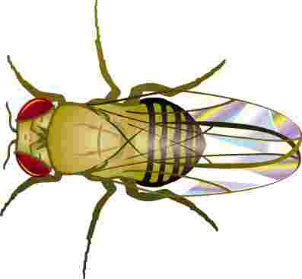
3. Show the cross of a white eyed female X ^{r} X ^{r} with a red-eyed male X ^{R} Y .

4. Show a cross between a pure red eyed female and a white eyed male.
What are the genotypes of the parents:
___________& _______________

How many are:
white eyed, male___
white eyed, female ___
red eyed, male ____
red eyed, female ____

5. Show the cross of a red eyed female (heterozygous) and a red eyed male. What are the genotypes of the parents?
___________ & ________________

How many are:
white eyed, male___white eyed, female ___
red eyed, male ____ red eyed, female ____
Math: What if in the above cross, 100 males were produced and 200 females. (think about the percentage of the total #)
How many total red-eyed flies would there be?
6. ____________

7. In humans, hemophilia is a sex linked trait. Females can be normal, carriers, or have the disease. Males will either have the disease or not (but they won’t ever be carriers)

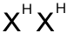 = female, normal  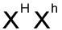= female, carrier  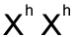 = female, hemophiliac | = male, normal  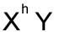= male, hemophiliac

Show the cross of a man who has hemophilia with a woman who is a carrier.

8. What is the probability that their children will have the disease? __________

9. A woman who is a carrier marries a normal man. Show the cross. What is the probability that their children will have hemophilia? What sex will a child in the family with hemophilia be?

10. A woman who has hemophilia marries a normal man. How many of their children will have hemophilia, and what is their sex?

