What does Biology mean?
Latin Root Words.
- Pro
- Eu
- Kary/Nucle
- Mito
- Reticulum
- Hyper
- Hypo
- Tonic
- Osmos
- Endo
- Exo
- Photo
- Synth
- Sis
- Chloro
- Plast
- Auto
- Troph
- Hetero
- Thylakoid
- Grana/Granum
- A/an
- Aero
- Crista
- Matrix
- Glyco
- Lys

- List the 7 characteristics of Life
- Know the 7 steps of the scientific method.
- Describe the difference between on observation and an inference.
- Know how to set up an experiment and identify its parts.
  - Independent Variable
  - Dependent Variable
  - Controlled Variables
  - Control Group
  - Experimental Group
- Two groups of students were tested to compare their speed working math problems. Each group was given the same problems. One group used calculators and the other group computed without calculators. Identify the independent variable, dependent variable, controlled variables, control groups and experimental groups
I: _________________________
D: ________________________
C: _________________________
CG: ________________________
EG:________________________
- Design an experiment with an independent variable, dependent variable, controlled variables, control group and experimental group based on the following hypothesis.
“Lemon trees receiving the most water produced the most lemons.”
I: _________________________
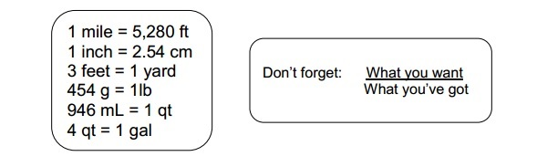
D: ________________________
C: _________________________
CG: ________________________
EG:________________________

Dimensional Analysis

  - 5,400 inches to miles b. 16 weeks to seconds

  - 54 yards to mm b. 36 cm/sec to mph
- You’re throwing a pizza party for 15 people and figure that each person will eat 4 slices. You call up the pizza place and learn that each pizza will cost you $14.78 and it will be cut into 12 slices. How much is the pizza going to cost you? You only have $70. Will you have enough money?
- In my chemistry class, 28 students are each given 3 pens. If there are 8 pens in one package, priced at $1.88 per package, what is the total cost of giving away pens?
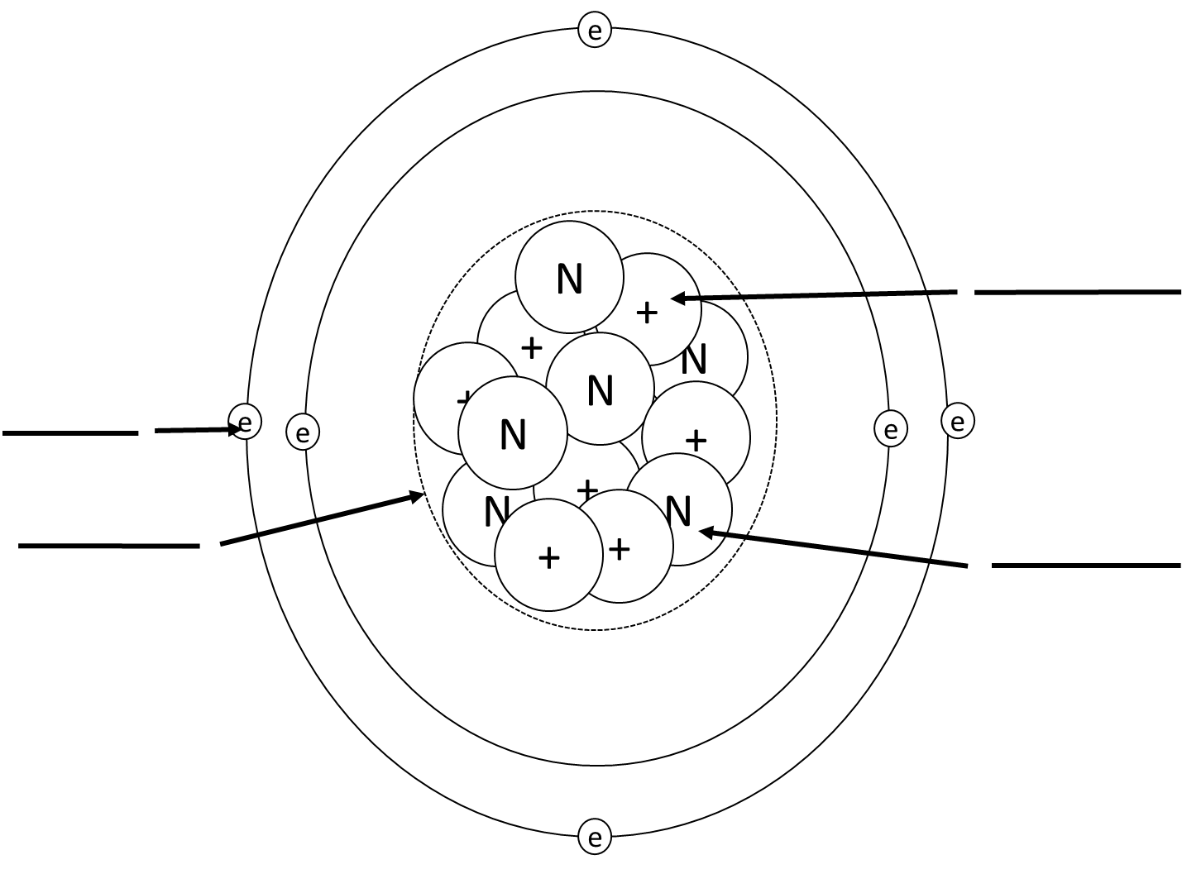
- Label the atom with the correct parts.

- Describe what a valence electron is and why it is important.

- Describe the difference between a balanced atom, an ion, and an isotope.

- Draw a polar and non polar molecule and describe why and how they are different.

  - How:
  - Why:

Match the following bonds with the correct description.
- _____Covalent a. this bond occurs between two polar molecules and is caused by the attraction of
positive charges to negative charges. This bond is considered weak.

- ______Hydrogen b. this bond occurs between two ions and is caused by the attraction of positive
charges to negative charges. This bond is considered strong.
- ______Ionic c. This bond occurs between two atoms and is caused by the sharing of electrons. This
bond is considered strong.
Define the following words: List the four Macromolecules/Polymers, their monomers, and one function
Polymer
Monomer
Function
- Macromolecule -
- Monomer –
- Polymer -
- What makes a compound organic?
- Be able to read the pH scale. Label each solution’s pH as either acidic, neutral or basic.
5 _________ 10 __________ 2___________ 7______________
- Explain how enzymes work like coupons.

- What are the three parts of the cell theory?
- ______________________________________________________
- ______________________________________________________
- ______________________________________________________
- What is the major difference between a eukaryote and a prokaryote
Match the following organelle with the correct description.
- _____Nucleus a. Creates food and energy for plant cells only.
- _____Nucleolus b. Creates Proteins
- _____Rough Endoplasmic Reticulum c. Gatekeeper of the cell.
- _____Smooth Endoplasmic Reticulum d. stores water
- _____Lysosome e. creates ribosomes
- _____Cell membrane f. creates lipids and destroys toxins/poisons
- _____Cell Wall g. stores DNA
- _____Golgi Apparatus h. Structural support and helps cell move.
- _____Vesicle i. destroys and breaks down invaders
- _____Ribosomes j. makes proteins and transfers them to the golgi apparatus
- _____Cytoskeleton k. makes energy
- _____Mitochondria l. packages proteins and puts them into labeled vesicles
- _____Chloroplast m. provides protection for plant cells only
- _____Vacuoles n. transports material in, around and out of the cell.

- Draw a phospholipid. Label its parts and the properties that they have.

- Draw and describe a phospholipid bilayer.

- What other things can be found in the cell membrane?

Define the following words: Compare and Label the two solutions:
40% H2O
60% Solute
40% H2O
60% Solute
63% H2O
37% Solute
90% H2O
10% Solute
78% H2O
22% Solute
80% H2O
20% Solute
- Hypertonic 52. 53. 54.
- Isotonic
- Hypotonic

55. There are two types of cellular transport. Active transport and passive transport. What is the major difference between these two types of transports?
The three types of passive transport are Diffusion, Facilitated Diffusion and Osmosis. Fill in the blanks to correctly define these types of transport.
56. Diffusion is the movement of ___________ from an area of _______ solute concentration to an area of _________ solute concentration until _________________ is met.
57. Osmosis is the movement of ____________ from an area of ______ water concentration to an area of _________ water concentration until ____________ is met.
58. Facilitated diffusion is the movement of __________ solutes with the help of ____________ ___________ embedded within the cell membrane.
The two types of active transport are Endocytosis and Exocytosis. Both of these types of transport require energy in the form of ATP to work. Fill in the blanks correctly to define these types of transport.
59. Endocytosis is the movement of material _______of the cell and requires energy in the form of ATP.
60. Exocytosis is the movement of materials ________of the cell and requires energy in the form of ATP.
61. When diffusion occurs the solutes travel from a ________________ solution to a _________________ solution.
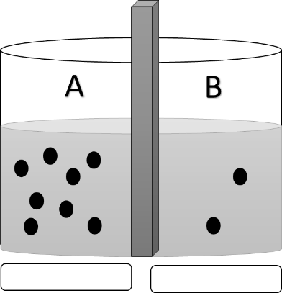
62. When osmosis occurs, water travels from a ______________ solution to a _______________ solution.

63. Solution A is ______________ to solution B.
64. Solution B is ______________ to solution A.
65. If the membrane separating the two solutions is permeable to the solutes what type of passive transport will occur?
Cells and Osmosis. Three cells are put into three different solutions. Describe how the water will move and what will happen to the cell.
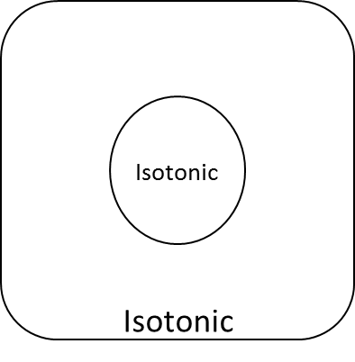
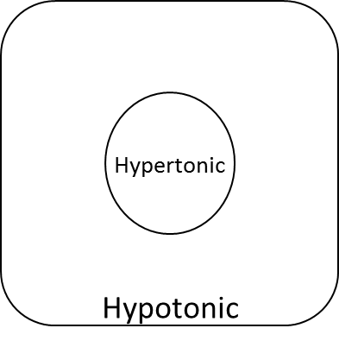
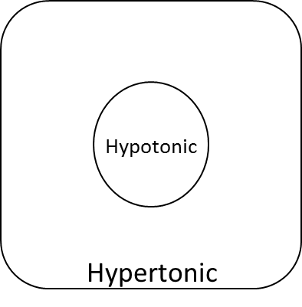
69. The water will: 71. The water will: 73. The water will:

70. The cell will: 72. The cell will: 74. The cell will:

75. Draw and describe the function and purpose of an ATP molecule. Make sure to include how it is recharged.

76. Know the difference between an autotroph and a heterotroph.
77. Write out the formula for Photosynthesis. Know what is required and what is created.
78. Write out the formula for Cellular Respiration. Know what is required and what is created.

79. Know the difference between anaerobic respiration and aerobic respiration.
80. Know the phases of aerobic cellular respiration.
81. Cellular respiration occurs in the _______________ (organelle). Photosynthesis occurs in the _______________ (organelle)
82. What is a chromosome?
83. Describe why DNA needs to be condensed and the 4 phases of condensation it undergoes.
84. Know the difference between a Diploid cell and a Haploid cell.
84. Draw and label a chromatid before and after S phase

85. Know the phases of the Cell Cycle. Fill in the phases of the cell cycle
Interphase:
G1:
S:
G2:
M Phase
Mitosis:
Prophase:
Metaphase:
Anaphase:
Telophase:
Cytokinesis:
Draw the placement of the chromosomes, centrioles, nucleus, and spindle fibers in the four stages of Mitosis.
Prophase Metaphase Anaphase Telophase

