Color the Microscope Parts
The most familiar type of microscope is the standard light microscope. The base (L) and arm (G) are usually one single piece of cast metal. The arm is the correct place to grip the microscope when carrying it while supporting the base with the palm of your other hand. Color the arm green and the base red. The stage (I) is the platform that supports the specimen to be observed. The stage has a hole in its center to allow light to pass through, so specimens must be positioned over the top of this hole. Color the stage blue. You can control how much light goes through the specimen by adjusting the diaphragm (K). It has a range of 1 to 5, with 5 being the most light. Color the diaphragm light green. Since any slight movement of the specimen is magnified many times, the slide is usually held down by a pair of stage clips (J). Color the stage clips gray.
Light microscopes use either a bulb or a mirror (M) as their light source. Never use direct sunlight; it may damage your eyes. Color the light source yellow. The switch for this light is usually found on the base of the microscope, and sometimes on the power cord.
After the light has passed through the specimen, it enters the objective lens (often called "objective" for short). The shortest of the three objectives is the scanning-power objective lens (N), and has a power of 4X. Color the 4X objective black. The second objective is the low-power objective (F), which is almost always made to produce a magnification of 10 times (10X). Color the low-power objective purple. The high-power objective lens (H) has a magnification of 40X. Draw orange stripes on the high-power objective.
The body tube (C) allows the light from the objective to pass upward to form the first magnified image; that image is further magnified by the eyepiece or ocular (A). The eyepiece is usually 10X. Color the body tube brown and the ocular lens orange.
The total magnification obtained is the product of the eyepiece times that of the objective lens. You can easily switch objectives by turning the rotating nosepiece (E). Color the nosepiece blue-green.
The coarse adjustment knob (B) is the larger on your microscope. You will use this primarily to focus on your specimen. DO NOT USE THE COARSE ADJUSTMENT KNOB ON HIGH POWER (40X), it will crack your slide. Color this knob pink. The fine adjustment knob (D) is also for minute focusing. You use this after you have focused with the coarse adjustment knob. Color this knob tan. The top part of the microscope that supports the ocular lens and the objective lens is not labeled on your image. Color this area to match the base.

QUESTIONS:
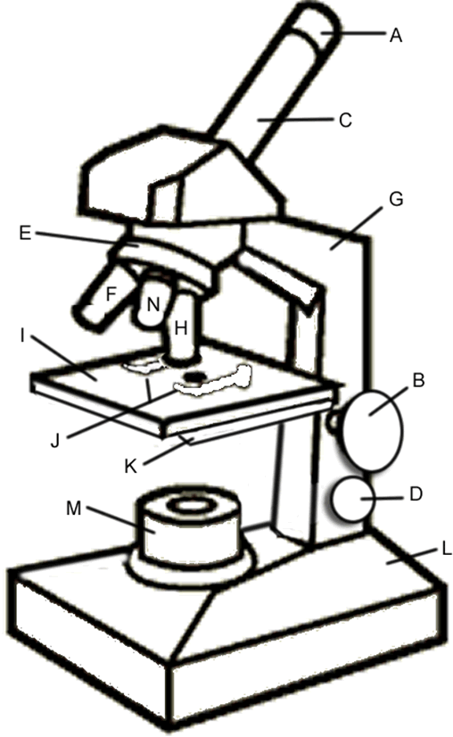
1. What two structures on the microscope will you use to focus on your specimen?
2. Why should you never use the coarse adjustment knob on high power?
3. What will happen if you use direct sunlight to observe your specimen?
4. Our microscopes have three objectives. What are their powers?
5. What is the magnification of the ocular lens?
6. What is the shortest objective called?
7. How do you switch objectives?
8. Which structure controls how much light passes through the specimen?
9. You should carry the microscope by placing your palm on the _____________________ and gripping the ___________________ with your other hand.
10. How can you prevent your slide from slipping on the stage?

