Plant Electron Transport Chain

This electron transport chain is located in the: _________ of the ______________________. _________________



________________

Where:

Input:

ATP + NADPH

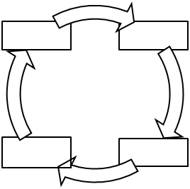

ADP + Pi, NADP+

Output:

To Stroma:

Out of Cell:

________________

Where:

Input:

Output:

To Stroma:

Out of Cell: