Article: Good Enough to Eat
Some scientists say we should use insects to help feed the world's growing population. Would you give bugs a try?
OCTOBER 26, 2012
By Suzanne Zimbler
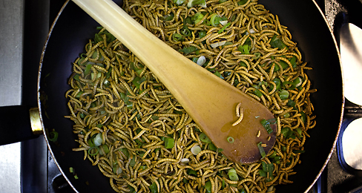
JERRY LAMPEN—REUTERS

Does a crunchy grasshopper taco sound yummy? If you were living in another part of the world—say, Mexico or Thailand or Kenya—the idea of biting into insects might not seem weird to you at all. For thousands of years, entomophagy, or insect-eating, has been common practice among many of the world's people. According to bug-eaters around the globe, insects are tasty. "When they are roasted, I find termites really delicious," Arnold van Huis of Wageningen University in the Netherlands told TFK.
Van Huis is an entomologist, or bug scientist. He is also an expert on bug-eating. He has traveled the world to learn how different groups of people gather insects and prepare them as food. It was in Kenya that Van Huis tried the termites. In Thailand, he had "nicely seasoned" locusts.
Bug fans say insects are not only tasty, they are also nutritious. Many are packed with protein, vitamins and minerals. Van Huis is working with other scientists to encourage insect-eating in areas where it is already common, as well as in Europe and North America, where people are more likely to squash a bug than swallow it.
Meat of the Future?
According to the United Nations, the planet's population is now almost 7 billion. It is expected to reach 9 billion before 2050. By that time, demand for meat is expected to double. Raising livestock requires large areas of farmland, and feeding the animals can be expensive. "We have to find alternatives to meat," Van Huis says. "One very good option is using insects."
Raising insects, which are able to live in crowded quarters, would require less land, says Van Huis. Bugs would also be cheaper to feed, since they could eat food scraps, such as potato peels. "We throw away one-third of our food," he says. "Insects could grow on that."
Not only could bugs eat our scraps, but they also would require much less food—and water—than livestock. According to Brian Fisher, an entomologist at the California Academy of Sciences, insects are efficient creatures. "A cow wastes most of its energy just keeping warm," he says. But since insects are cold-blooded, they use more of what they eat to grow.

Crunch Time
For insect-eating to become mainstream in the U.S., Fisher says people must have a chance to sample tasty, ready-to-eat bugs. There are more than 1,700 types of bugs that are safe to eat. But do not even think of snacking on bugs from your backyard, since there is no way of knowing if they are dangerous! If you're in the mood for bugs, it is possible to order insect cuisine at a handful of U.S. restaurants. At Toloache, a Mexican restaurant in New York City, chef Julian Medina prepares tacos stuffed with chapulines, or little grasshoppers, which he imports from Mexico. "We can sell 10 or 15 orders a day," he says.
Van Huis is working with chefs in the Netherlands to develop scrumptious bug recipes. For one experiment, his team prepared two types of meatballs: some made with plain meat and others made with mealworms and meat combined. In a blind taste test, nine out of 10 people preferred the mealworm meatballs.
In the future, will eating insects be common practice for people in Europe and North America? "I'm absolutely sure it will," says Van Huis. Care for a Bug Mac, anyone?

